Machine

Session date | 2012-01-02
Session time | 02:12:04
Machine axis name | AX7
SAT version | 04.96.00.00.001
Serial number
Report date | 2012-01-02
Report time | 02:15:52
XML file

Position Loop

Bode Plots

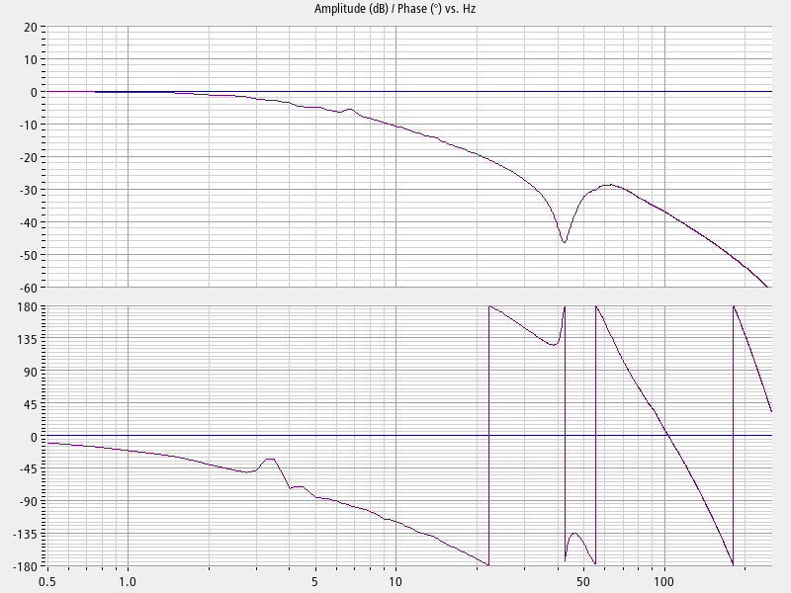
Standalone optimal:
Calculated closed position loop without FFW ——
Measured closed position loop ——

Parameters

 | Standalone optimal | Autotuned standalone optimal | Initial platform configuration
Kv factor | 1 | 1 | 1 | 1000/min
Feed forward type | Speed | Speed | Speed
Speed ctrl EQ time for speed FFW | 0.000625 | 0.000625 | 0.000625 | s
Speed ctrl EQ time MD32810 | 0.003 | 0.003 | 0.003 | s
Curr ctrl EQ time for Torque FFW | -0.0005 | -0.0005 | -0.0005 | s
Curr ctrl EQ time MD32800 | 0.0005 | 0.0005 | 0.0005 | s
Speed delay time (P1429) | 0 | 0 | 0 | s
Inertia for torque FFW | 0 | 0 | 0 | kgm²
DSC active | False | False | False
Estimated dead time | 0.003125 | 0.003125 | 0.003125 | s
Interpolation speed pre-control | 1 | 1 | 1
Interpolation supplementary torque | 0 | 0 | 0
FFW always active | False | False | False
Jerk filter enable | False | False | False
Jerk filter type | 1 | 1 | 1
Jerk filter time | 0.001 | 0.001 | 0.001 | s
Jerk filter time 2 | 0.001 | 0.001 | 0.001 | s
Dyn match filter mode (MD32902) | 0 | 0 | 0
Dynamic match filter time (MD32910) | 0 | 0 | 0 | s
Desired value delay time (MD32895) | 0 | 0 | 0 | s
Total time constant | 0 | 0 | 0 | s
Update time | 0.002 | 0.002 | 0.002 | s

Standalone optimal:
 |  | Frequency | Damping | Num freq | Num damp | Res | EN
SS | PT1 | 1e+200
SS | PT1 | 1e+200

Autotuned standalone optimal:
 |  | Frequency | Damping | Num freq | Num damp | Res | EN
None

Initial platform configuration:
 |  | Frequency | Damping | Num freq | Num damp | Res | EN
None

Speed Loop

Bode Plots

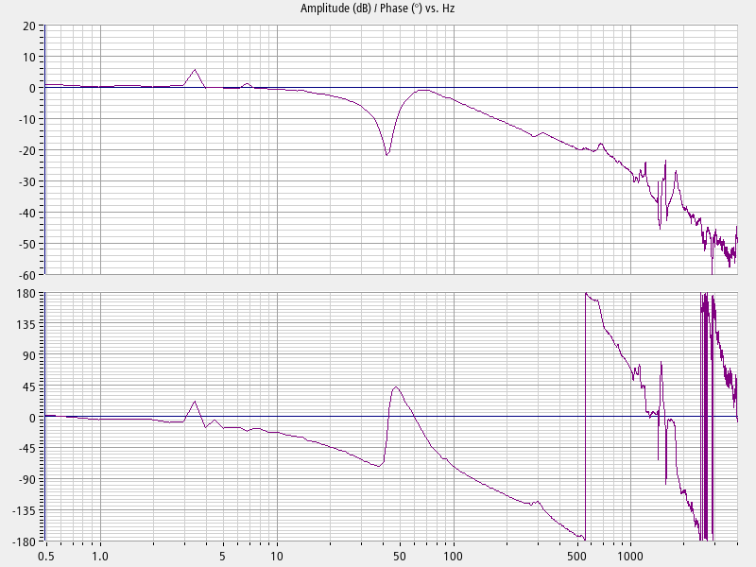
Standalone optimal:
Calculated closed speed loop ——
Measured closed speed loop ——

Parameters

 | Standalone optimal | Autotuned standalone optimal | Initial platform configuration
Proportional gain Kp | 22.24 | 22.24 | 25.45 | Nms/rad
Integral time Tn | 0.035 | 0.035 | 0.01 | s
Reference model active | True | True | False
Reference model frequency | 37.57 | 37.57 | 0 | Hz
Reference model damping | 0.7071 | 0.7071 | 1
Reference model time | 0 | 0 | 0 | s
Estimated total inertia | 0.1468 | 0.1468 | 0.1468 | kgm²
Motor inertia | 0.076 | 0.076 | 0.076 | kgm²
Lowest freq. zero of mech. plant | 41.52 | 41.52 | 41.52 | Hz
Update time | 0.000125 | 0.000125 | 0.000125 | s

Standalone optimal:
 |  | Frequency | Damping | Num freq | Num damp | Res | EN
CS | Low-pass (PT2) | 2000 | 0.7071 |  |  | X | X
CS | 2nd order | 1566 | 0.25 | 1566 | 0.1022 |  | X
CS | Low-pass (PT2) | 1999 | 0.7
CS | Low-pass (PT2) | 1999 | 0.7

Autotuned standalone optimal:
 |  | Frequency | Damping | Num freq | Num damp | Res | EN
CS | Low-pass (PT2) | 2000 | 0.7071 |  |  | X | X
CS | 2nd order | 1566 | 0.25 | 1566 | 0.1022 |  | X

Initial platform configuration:
 |  | Frequency | Damping | Num freq | Num damp | Res | EN
CS | Low-pass (PT2) | 1999 | 0.7 |  |  |  | X

